**Q1.  What is RPA – Robotic Process Automation?**

|  |  |
| --- | --- |
| ***Robotic*** | Machines which mimic human actions are called Robots. |
| ***Process*** | Sequence of steps which lead to a meaningful activity. For example the process of making tea etc. |
| ***Automation*** | Any process which is done by a robot without human intervention. |

To sum it up, mimicking human actions to perform a sequence of steps that lead to a meaningful activity, without any human intervention is known as Robotic Process Automation.

Now, this is the most generic question asked in RPA Interview Questions. Now let’s move forward and see the benefits of it.

[**Get Certified In RPA Now!**](https://www.edureka.co/robotic-process-automation-training)

**Q2.  What are the benefits of using RPA?**

**Benefits of using RPA**

1. **It Saves Cost:**Since it can automate almost all manual and repetitive tasks, you can reduce the size of your workforce and hence reduce costs.
2. **More Accurate in Lesser Time:**To err is human, but computers or machines don’t commit any mistakes, they do exactly as they are told and hence are more accurate.
3. **Easy to Implement and learn:**Like earlier stated, there is no coding required. Any automation can be created using a simple drag and drop.
4. **No Coding Required!:**RPA can be implemented to automate any repetitive process which is done on a computer. This process can be related to any desktop tool or web application, if the process is repetitive it can be automated, that too with minimum coding required.

**Q3.  What is the difference between UiPath vs BluePrism vs Automation Anywhere?**

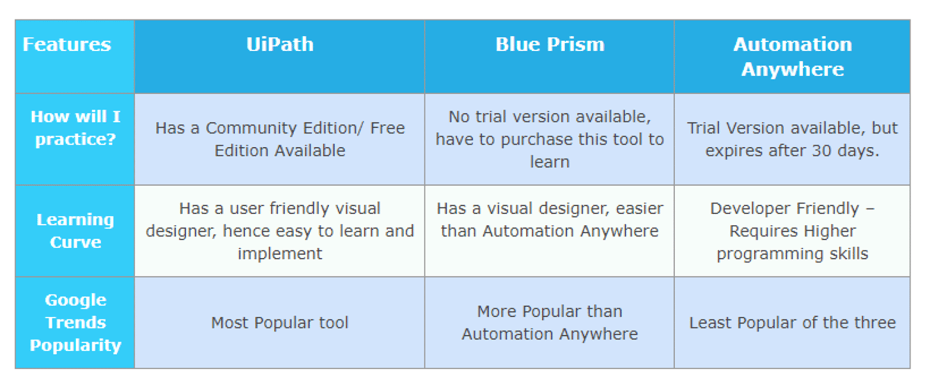

**Q4.  What are the characteristics of RPA?**

**Code Free:**RPA doesn’t require programming skills. Employees with any subject expertise can be trained to automate RPA tools instantly. The whole work revolves around RPA chart which provides a flowchart designer to graphically link, drag and drop icons to represent steps in a process.

**User-Friendly:**RPA adoption originates within business operations rather inside IT departments. RPA projects require less IT skills and less investment. Eventually, the automation is lowered at a substantial rate.

**Non- Disruptive:**RPA avoids complexity and risk. The software robots access to end user’s systems via a controlled user interface, hence reducing the necessity of underlying systems programming.

**Q5.  What are the important Phases of RPA Life Cycle?**

**Phases of RPA Life Cycle:**

**Analysis**: The first phase in RPA begins with analysis. Business team and RPA Architect work together to understand a business process for RPA development.

**Bot Development**: RPA developer (Team) starts working on the requirement in their environment possibly a distinct development environment.

**Testing**: Some companies conduct Testing by Separate Testing Team, while some have a dedicated testing team which performs a dedicated QA like normal SDLC flow. Best Practice is to have a dedicated testing team which performs QA of a developed bot.

**Deployment and Maintenance**: After the Development and Testing phases, a bot is ready for distribution and enters maintenance phase.

This question is frequently asked in RPA interviews. You should know the RPA Life Cycle.

**Q6.  How is a chatbot different from robotic process automation?**

The difference between a chatbot and an RPA engine is similar to a difference between a mouse and a mammoth. By the names,

**ChatBot**– A bot programmed to chat with a user (human) like a human. Possibly to recommend a pre-learned resolution to a particular problem that user faces or to take a request and instruct backend systems to provision a request.

**RPA (Robotic Process Automation)**– A bot programmed to automate a manual business process of executing a task or an activity within a business function. A business function can be like HR/Finance/Procurement etc. A chatbot can be a medium to feed an input into an RPA engine but cannot replicate the features of an RPA engine.

**Q7.  What is the difference between traditional / IT automation and RPA?**

* Traditional IT Automation is long drawn and requires considerable manpower, time, effort and substantial cost.
* RPA is a quick fix to instantly generate improvements.
* Both traditional automation and RPA need solid strategy and planning but the implementation of RPA is quick.
* While both are aimed towards the common goal of Automation, RPA is faster, better and cheaper than traditional automation. Therefore Traditional Automation is a strategic move and RPA is a tactical move.
* In short, if you have the luxury of having time and budget, look for traditional automation. If you have business pressures right now on time and money, go for RPA

**Q8.  How long does it take to establish the Operational Agility framework?**

The average time to establish the initial Operational Agility framework is between 4 and 12 weeks from project initiation.

**Q9.  What is the difference between UiPath and Selenium?**

**Selenium** is specifically designed to test web applications and websites, it is impossible in selenium to interact with multiple applications and taking the output of one application as an input for other application. It cannot work with Virtual environments like Citrix etc at all. While **UiPath** is an RPA tool which is designed to automate any type of existing software process to replace any type of activities that can be performed by a human. So we can say that RPA is the next level of existing automation tools. It allows people to build a very complex rules-based process with very little software development skills. You can do all things using UIiPath which can be done by Selenium but vice-versa is not possible. You can also look at my below articles for more details on these tools.

**Q10.  What are the general requirements of RPA for front and back office processing?**

Well, the fact is RPA is well-known for its flexibility and it is capable to meet the robust IT standards without compromising the security. It is possible to use the robotic software for front and back office. Most of the requirements are same for both and thus users need not worry. The same configuration can easily be deployed and the results that can be derived are always superior in every aspect.

**Q11.  During the planning phase of automation, what points are to be considered on priority?**

After selecting the tool which is the first task, next big thing that matters a lot is selecting the right **framework**. There are various items that are tagged as **In scope** and **Out** **Scope** that need to be selected based on the type of task. After this, the test **environment** is to be considered. If required, users need to prepare the charts of project timelines. At the same time, **identification** of **deliverables** is another major factor that is to be considered.

**Q12.  What do you by mean by the term Information Collection in RPA?**

In RPA, robots need raw data or information to perform their operations smoothly and reliably. They generally collect this information from different resources and it is also possible that the same can be provided to them manually.

**Q13.  With RPA, is it always necessary that an organization that needs to adopt this approach have to change its entire infrastructure? Why or why not?**

It is not always necessary that to adopt RPA everything needs to be changed in an organization. In fact, it can easily be made compatible with the existing infrastructure. This is mainly due to the fact that the latest robotic software and tools in RPA doesn’t face any compatibility issues easily and can simply enable the organizations to keep up the pace.

**Q14.  How can you say that Robotic Process Automation is a secure and reliable approach?**

At several levels, the same is built in the RPA. The good thing is with all the vendors, runtime factor is totally different to the process which is related to the editing of anything. It is not necessary that all the users are given the same actions but in fact, they can be restricted. This generally includes creating, designing, running, as well as editing the processes. Every log created is capable to provide full information with a wide scope. As compared to a manual process, RPA provides extra control, as well as security.

**Q15.  Is Robotic Automation like screen scraping or macros?**

No, managerial Robotic Automation is a generation from old technologies like screen scratching or macros. The major differences are: Robots are universal application orchestrators – any application that can be used by a man can be used by a present-day robot, whether mainframe, bespoke application, legacy, web service enabled or even a close 3rd party API hosted service. Robots assemble procedural knowledge which after some time joins with a shared library that can be re-used by some other robot or device. Applications are “read” by the robot, either through submitted APIs where they exist, through the OS before application appears, or through the screen with respect to the native application. In this last case the modern robot “reads” an application screen in context and in the same way a user does. As part of the robot training, it is shown how to read the application’s display much like a user is shown.

[**Learn From Indusrty Experts**](https://www.edureka.co/robotic-process-automation-training)

**Q16.  What is the difference between thin client and thick client?**

**Thin client**: It is an application that we cannot get the quality properties while spying using any RPA tool.e.g.  Any virtual environment.

**Thick client**: It is an application that we get a pretty handful of attribute features using RPA tool e.g. calculator, Internet Explorer

**Q17.  What is the difference between Mainframe and Non-Mainframe Applications?**

**Mainframe applications:**

* It’s a single screen and keyboard-based application.
* There are separate set in-built commands supported by Blue Prism especially for mainframe applications

**Non-mainframe applications:**

* It includes multiple screens
* Control moves from one screen to another screen.

**Q18.  What are session variables?**

Session Variables are particular to that instance of the Process. If 2 instances of the same process are continuing at the same time, they both have the same session variables, but the session variables values will be different.

**Q19.  What does publishing an automation project mean in UiPath?**

Publishing of the automation package indicates archiving it and the related files present in particular folder for sending it to robots and then executing it. When you will be connected to the orchestrator then the project will go to the orchestrator field and then it will be displayed on packages page. And from this place, you can easily distribute them to the other robots after you assign some packages to the environment. Otherwise, it will get stored locally in the Studio feed.

**Q20.  What is Project Debugging in UiPath?**

Debugging is the process of identifying and removing errors from a given project. Coupled with logging, it becomes a powerful functionality that offers you information about your project and step-by-step highlighting, so that you can be sure that it is error-free. Logging enables you to display details about what is happening in your project in the **Output**panel. This, in turn, makes it easier for you to debug an automation. Breakpoints enable you to pause the execution of a project so that you can check its state at a given point.

**Q21.  What is tracing and how do you enable tracing in UiPath?**

By default, UiPath generates log files that track the activity of Studio and the Robots. These logs can be accessed from the **Execute** ribbon tab, by clicking the **Open Logs** button.For complex issues, more details about your automation are needed. To gather them, tracing must be enabled.In **UiPath Studio**, tracing generates a .etl file. It contains binary log data at the trace level, such as disk accesses or page faults, and is used to log high-frequency events while tracking the performance of an operating system.

**RPA UiPath Interview Questions: Basic UiPath Questions**

**Q22.  In UiPath studio, which recorder is suitable for Virtual Environment Automation?**

Citrix Recorder

**Q23.  How can we identify a Column in a database in UiPath Studio?**

We can identify a Column by:

* Using a Column Index
* Using a Column Name

**Q24.  Which activities can be used to iterate through an array in UiPath Studio?**

Following are the activities that can be used to iterate through an array in UiPath Studio

* For each Activity
* While Activity

**Q25.  If we scrape some text and we know it contains only digits, how can we make the scrape better?**

By using Google OCR with “Numbers Option” only.

**Q26.  Is it possible to click a button using the Click Image Activity if it’s not visible to the human eye?**

No, this is only possible with Selectors.

**Q27.  How can you get a value from an application, if it changes for each transaction?**

This could be done by finding a static element and then use Scrape Relative functionality to extract the value.

**Q28.  What does the Accuracy property represent in the Click image activity?**

It is a unit of measurement from O to 1 which expresses the minimum similarity between the image you are searching for and the one to be found.

**Q29.  In UiPath studio, how elements are recognized on screen?**

They can be recognized through the attributes of UI elements.

**Q30.  What does Publishing mean in UiPath Automation Studio?**

Publishing of the automation package indicates archiving it and the related files present in particular folder for sending it to robots and then executing it. When you will be connected to the orchestrator then the project will go to the orchestrator field and then it will be displayed on packages page. And from this place, you can easily distribute them to the other robots after you assign some packages to the environment. Otherwise, it will get stored locally in the Studio feed.

**RPA UiPath Interview Questions: Questions related to UiPath Activities**

**Q31.  What is a single block activity in UiPath?**

Single Block Activity is the smallest type of project which is mainly called as Sequence. They are suitable for linear processes as they enable you to go from one activity to another seamlessly, and act as a single block activity. They can be reused time and again, as a standalone automation or as part of a state machine or flowchart.

**Q32.  What are Control Flow Activities in UiPath?**

**Control Flow** is a concept borrowed from computer science that refers to the order in which actions are performed in an automation. A proper **Control Flow** can be achieved through the intelligent use of variables and activities.

**Q33.  What is the Assign Activity in UiPath?**

The **Assign** activity is an important activity that is going to be used quite often, as it enables you to assign a value to a variable. You can use an **Assign** activity to increment the value of a variable in a loop, sum up the value of two or more variables and assign the result to another variable, assign values to an array and so on. By default, this activity is also included in the **Favorites** group. To remove it, right-click it and select **Remove**.

[**Learn RPA Now**](https://www.edureka.co/robotic-process-automation-training)

**Q34.  What is the Delay Activity in UiPath?**

The **Delay** activity enables you to pause the automation for a custom period of time (in the hh : mm: ss format). This activity proves itself quite useful in projects that require good timing, such as waiting for a specific application to start or waiting for some information to be processed so that you can use it in another activity.

**Q35.  What is the Do While Activity in UiPath?**

The **Do While** activity enables you to execute a specified part of your automation while a condition is met. When the specified condition is no longer met, the project exits the loop. This type of activity can be useful to step through all the elements of an array or execute a particular activity multiple times. You can increment counters to browse through array indices or step through a list of items.

**Q36.  What is the If Activity in UiPath?**

The **If** activity contains a statement and two conditions. The first condition is executed if the statement is true, while the second one (the activity in the **Else** section) is executed if the statement is false. **If** activities can be useful to make decisions based on the value of variables.

**Q37.  What is the Switch Activity in UiPath?**

The **Switch** activity enables you to select one choice out of multiple, based on the value of a specified expression. By default, the **Switch** activity uses the integer argument, but you can change it from the **Properties** panel, from the **TypeArgument** list. The **Switch** activity can be useful to categorize data according to a custom number of cases. For example, you can use it to store data into multiple spreadsheets or sort through names of employees.

**Q38.  What is the For Each Activity in UiPath?**

The **For Each** activity enables you to step through arrays, lists, data tables or other types of collections so that you can iterate through the data and process each piece of information individually.

**Q39.  What is the Break Activity in UiPath?**

The **Break** activity enables you to stop the loop at a chosen point and then continue with the next activity.

**Q40.  What is the While Activity in UiPath?**

The **While** activity enables you to execute a specific process repeatedly, while a specific condition is met. The main difference between this and the **Do While**activity is that, in the first one, the condition is evaluated before the body of the loop is executed. This type of activity can be useful to step through all the elements of an array or execute a particular activity multiple times. You can increment counters to browse through array indices or step through a list of items.

**Q41. How do you activate UiPath Studio license?**

**Online Activation**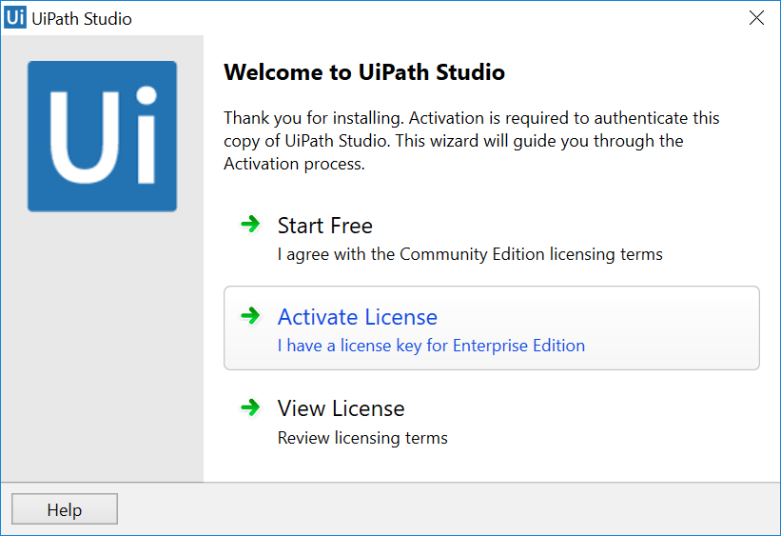

* Click the **Activate License** The UiPath Registration window is displayed.
* Fill in the **Email Address** field with your email address.
* Fill in the **License Key** field with the license key you received.
* Select the **Automatic activation**
* Click the **Activate** Your UiPath license is now activated and you can start creating automation workflows.

**Q42.  What is state machine in UiPath?**

A **State Machine**is a type of automation that uses a finite number of states in its execution. It can go into a state when it is triggered by an activity, and it exits that state when another activity is triggered. They also enable us to add conditions based on which to jump from one state to another. These are represented by arrows or branches between states.

**Q43. How do you install chrome Extension for UiPath Studio?**

**From UiPath Studio**

* In the Setup ribbon tab, from the **Setup Extensions** menu, select **Chrome**. The Chrome Web Store is opened in Google Chrome.

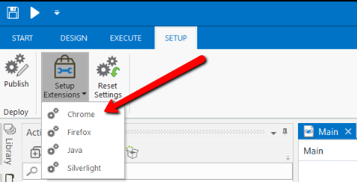

* Click the **Add to Chrome** A confirmation dialog box is displayed.
* Click the **Add extension** The extension is now installed.

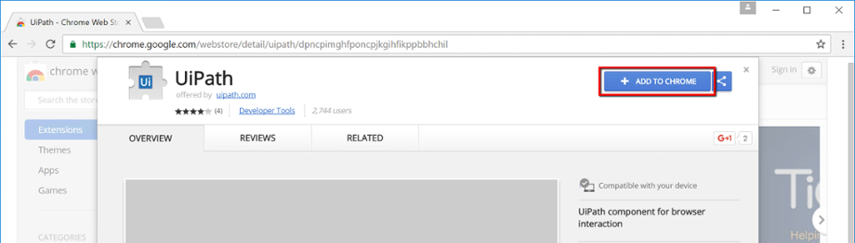

**Note:** Generally by default extension is off.

**Q44.  How to import Namespaces in UiPath?**

To add new namespaces to your library:

* Open the **Imports**
* In the **Enter or Select namespace**field, start typing the namespace that interest you. Note that suggestions are provided while you type in case you are not exactly sure what you are looking for.
* Click the drop-down arrow to view and browse all available namespaces.
* Select the desired namespace. The namespace is added to the **Imported Namespaces.**To remove a namespace, select it and press Delete. Note that namespaces can only be deleted if they aren’t used. For example, you can delete a namespace if the assembly that contains it is no longer referenced by the project.

[**Enroll Now!**](https://www.edureka.co/robotic-process-automation-training)

**Q45.  What are Arguments in UiPath?**

Arguments are used to pass data from a workflow to another Workflow.They have specific directions In/Out/InOut.

Arguments are used to pass data from a project to another. In a global sense, they resemble variables, as they store data dynamically and pass it on. Variables pass data between activities, while arguments pass data between automation. As a result, they enable you to reuse automation time and again.UiPath Studio supports a large number of argument types, which coincide with the types of variables. Therefore, you can create Generic Value, String, Boolean, Object, Array, or DataTable arguments and you can also browse for .NET types, just as you do in the case of variables. Additionally, arguments have specific directions (**In**, **Out**, **In/Out**, **Property**) that tell the application where the information stored in them is supposed to go.

**Q46.  Can UiPath run multiple instances of the same process with one robot in one system simultaneously?**

Yes, it can run the same program simultaneously in two robots where each system is registered as one robot. On a machine with a Windows Server (2008 R2 or 2012 R2 or 2016) operating system:

* You can run the same process with all Robots at the same time;
* You can run different processes with all Robots at the same time.

These are called **High-density** robots.

**Q47.  How do you expand a Tree View structure in a web page using UiPath?**

If you are talking about expanding the root node for a collapsed tree, you probably would use Click Image since that would likely be unique. If you are trying to expand a particular node, you’d likely use Click Text, and give it a certain negative X offset in the Position property so that when it targets the text you want to expand the node for, it will end up clicking on the +.

**Q48.  How will you price an RDA project to a customer?**

First, we will identify the **scope** of the automation like:

* How the business process flows.
* How many applications are involved?
* How complex the interactions between these applications.

Once we know all these then we will work out the number of bots to be deployed and estimate the cost for each bot to develop and deploy. This is how we do at a high level. Usually based on the complexity involved the project may go anywhere between 6–12 months.

**Q49.  When would you choose System Integration over RPA?**

I would prefer system integration if the return on investment (ROI) is better than deploying RPA. But you will find only a few projects which will have that scenario.

If you are working in the local environment and have similar kinds of platforms/software, try for system integration.System Integration will mostly require full access to the back end scripts and the timeline for deployment is most likely higher than RPA. If you are in back office operations, then you may find multiple platforms like legacy, GUI, and web-based all being used together. This creates complexity to system integration.

On the other hand, RPA software is platform agnostic. They could be configured from front end also with any kind of platform. The timeline is lesser and it’s easy to train or find RPA developers. Thus it’s a preferable choice to go with RPA.

**Q50.  How do I assess the processes for RPA and calculate FTE saves?**

There are no hard and fast rules, but the following are some desirable attributes that your identified process should possess:

* High transaction volumes
* Manual data entry and/or extraction
* Rule-based
* Multiple handling of the same data
* Disparate systems (especially legacy ones)
* Stable processes

Regarding the Full-Time Equivalent (FTE) savings, the concept is rather simple. You need to determine how long it takes for an employee to complete the transaction currently, and estimate the time it will take a bot to complete the same transaction. The time savings per transaction completed multiplied by the number of transactions will give you the figure you need. Note the above is meant to be a quick back-of-the-envelope calculation of the FTE savings. Also, the challenge when calculating the FTE savings (prior to implementing RPA) lies in justifying and validating the assumptions you have made.